This is a familiarization primer for your team to use to get started. Once you drive your vehicles and have some data built into your system the training by one of our on boarding specialists will be more meaningful. We will facilitate setting that up for you at your convenience.

Live Fleet view
- When we log in we are taken directly to the Live Fleet view
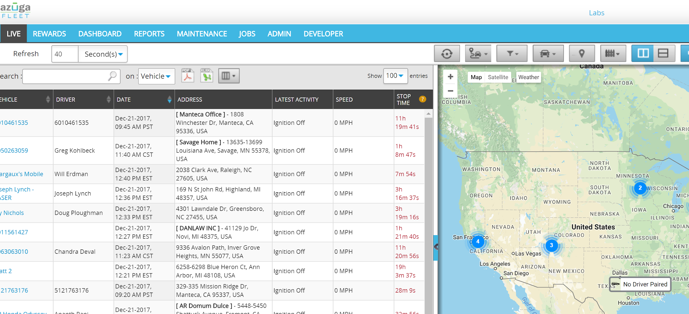

- The Live Fleet view is a simple view of your vehicle's divided into two parts
  - The lefts side shows the most recent events for your vehicles
  - The right side show you vehicles on a map
- The map on the right size is a self-sizing map. That means that it will expand or contract to show all of your vehicles regardless of where they are. If you had some in California and some in New York you would see the entire US map.
- Let’s take a look at the Live Events on the left size.
- < Unlike others, say something there>
- <If you were forced to skip the slide deck and had to jump to this demo, say a little bit about how big we are to establish credibility, which would otherwise have been established in the first slide>
- For now we are going to focus on the vehicle with the name Ironman All Features. This is actually a dummy vehicle that has data played back all the time to reflect as much functionality as Azuga has, but it’s always a work in progress as the product team keeps releasing new features. Sometimes, Ironman maybe behind our product releases. Engineering is trying to give it first class treatment so that it is always available, and up to date, starting July 15 2018.

  - On live maps, under the Date column we see the date and time of the last report
  - Next to that we see the location of the last report
  - And then the status. This shows that the vehicle is currently stopped
    - When a vehicle’s ignition is off it will still show a location every 4 hours. This can be adjusted to every hour.
    - Once the ignition is turned on it will immediately send a location with a report that the ignition has been turned on.

Reports

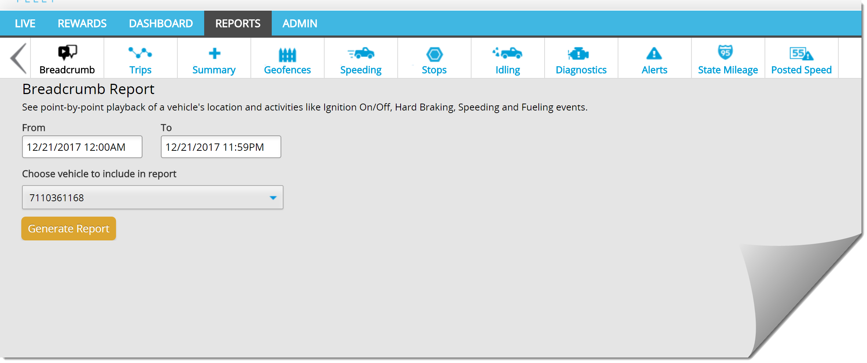

There are a variety of easy to read reports that allow you to see a summary of the operations along with the details.
- < Unlike others, say something here. Example. Our customers tell us that our app is intuitive and easy to use. Would love to hear your opinion if you’ve seen others or are using something now>
- <If you were forced to skip the usual slide deck and had to jump straight into this demo, say a little bit about how we are different. We have a team that generates custom reports and delivers it to your Inbox. We offer this premium service free of charge, unlike our competitors>

- Breadcrumb
  - This is the virtual ride along. It is almost like being in the vehicle with the driver
- Trips
  - Provides information on each trip
- Summary
  - This is a great report. It provide you with a summary of data over a day or a month. Easy to read and allows you to quickly identify areas that might need your attention
- Geofence
  - Entry, exit and time spent within a geofence (job or customer location)
  - Or notification of vehicle locations at places you would rather not have your vehicle and name associated with (Men’s Clubs).
- Speeding, Stop Times, and Idling
  - Our OBDII solution is the most accurate on the market.
- Distracted driving
  - If you use our Azuga Fleet Mobile app, we can capture texting, talking while driving and report it for you. As you know distracted driving is a national epidemic. And lawsuits are getting bigger. And businesses get hit harder because everyone believes you have deeper pockets!
- Diagnostics
  - Proactive attention to the most serious ones can save you thousands of dollars a year
- State Miles
  - Really simple to determine how many miles each vehicle had traveled by state
  - Especially help when it comes to road taxes
  - Never get overcharged again
- WWW - Who Was Where
  - Enter a location, date and time and see who was there or who was not. Helpful if you ever have a dispute or want to reconstruct a potential accident claim.
- Posted Speed Limits
  - One of our partner add on functions
  - Avoid your vehicles from speeding in school zones. That really gets people angry and they remember who they saw do it.
- Scheduled Reports
  - Schedule when and what reports you want and to whom.
  - Quick review with a nice hot cup of coffee

Breadcrumb/Virtual Ride-Along

- I mentioned the Virtual Ride-Along where you are in the vehicle with the driver
- I will show you what I mean
- Let’s take a closer look at the vehicle named Scott Hon CR-V. All you have to do is click on the name and we will see all of the activity for the day up to this moment.

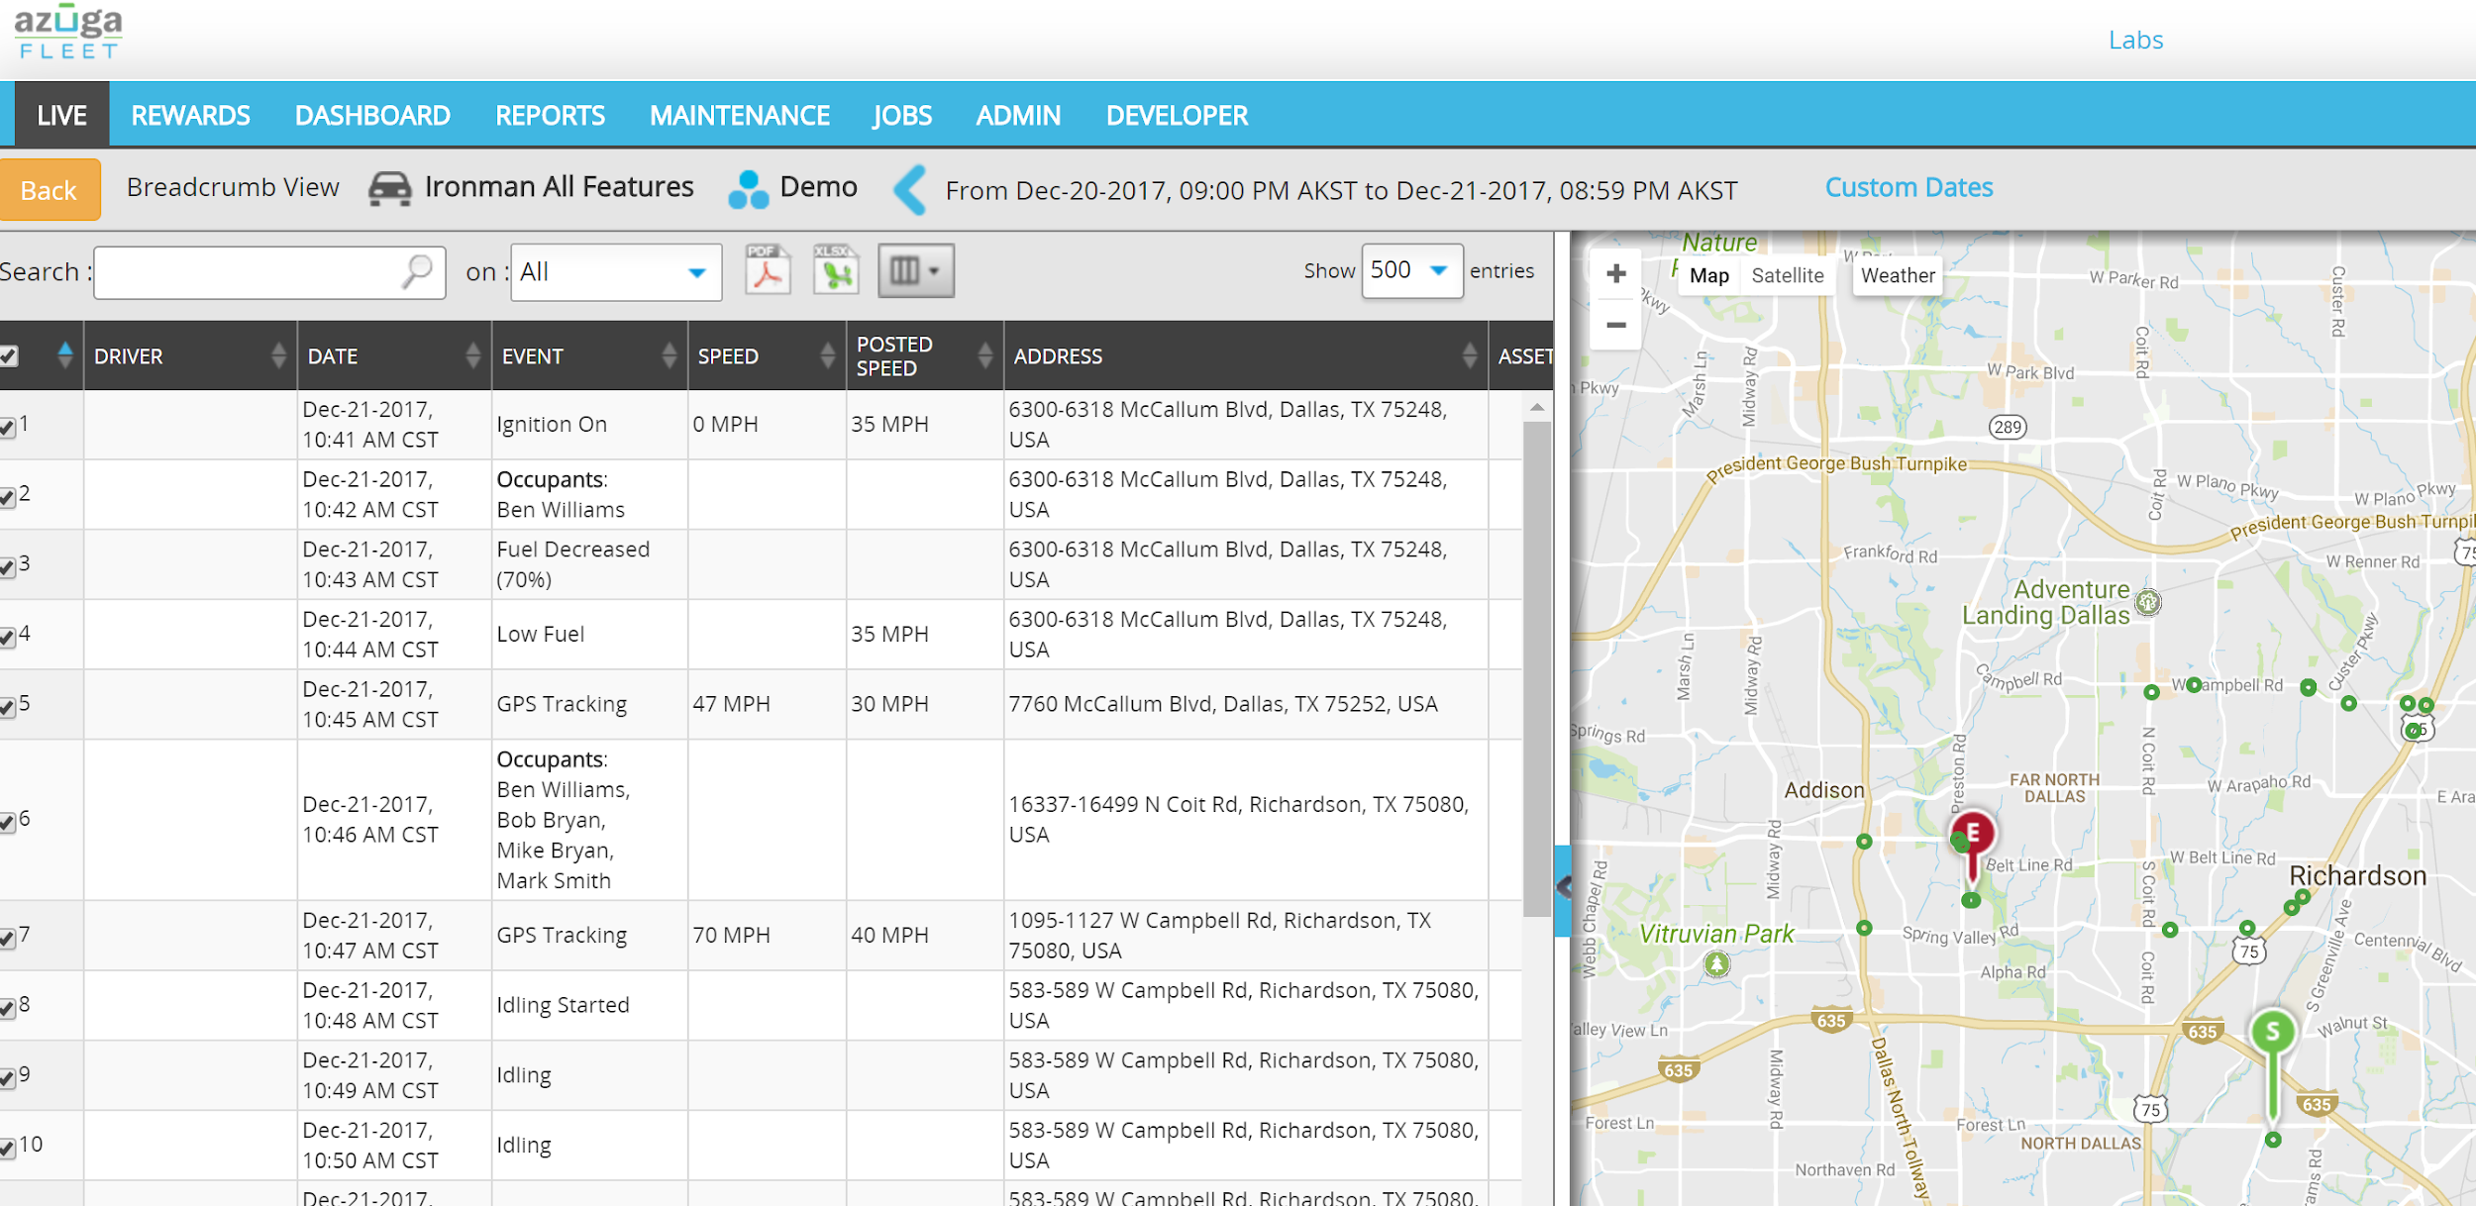

- This is called the Breadcrumb View. Just like a breadcrumb it shows you where the vehicle was plus what it was doing both in a text report event by event and on the map.

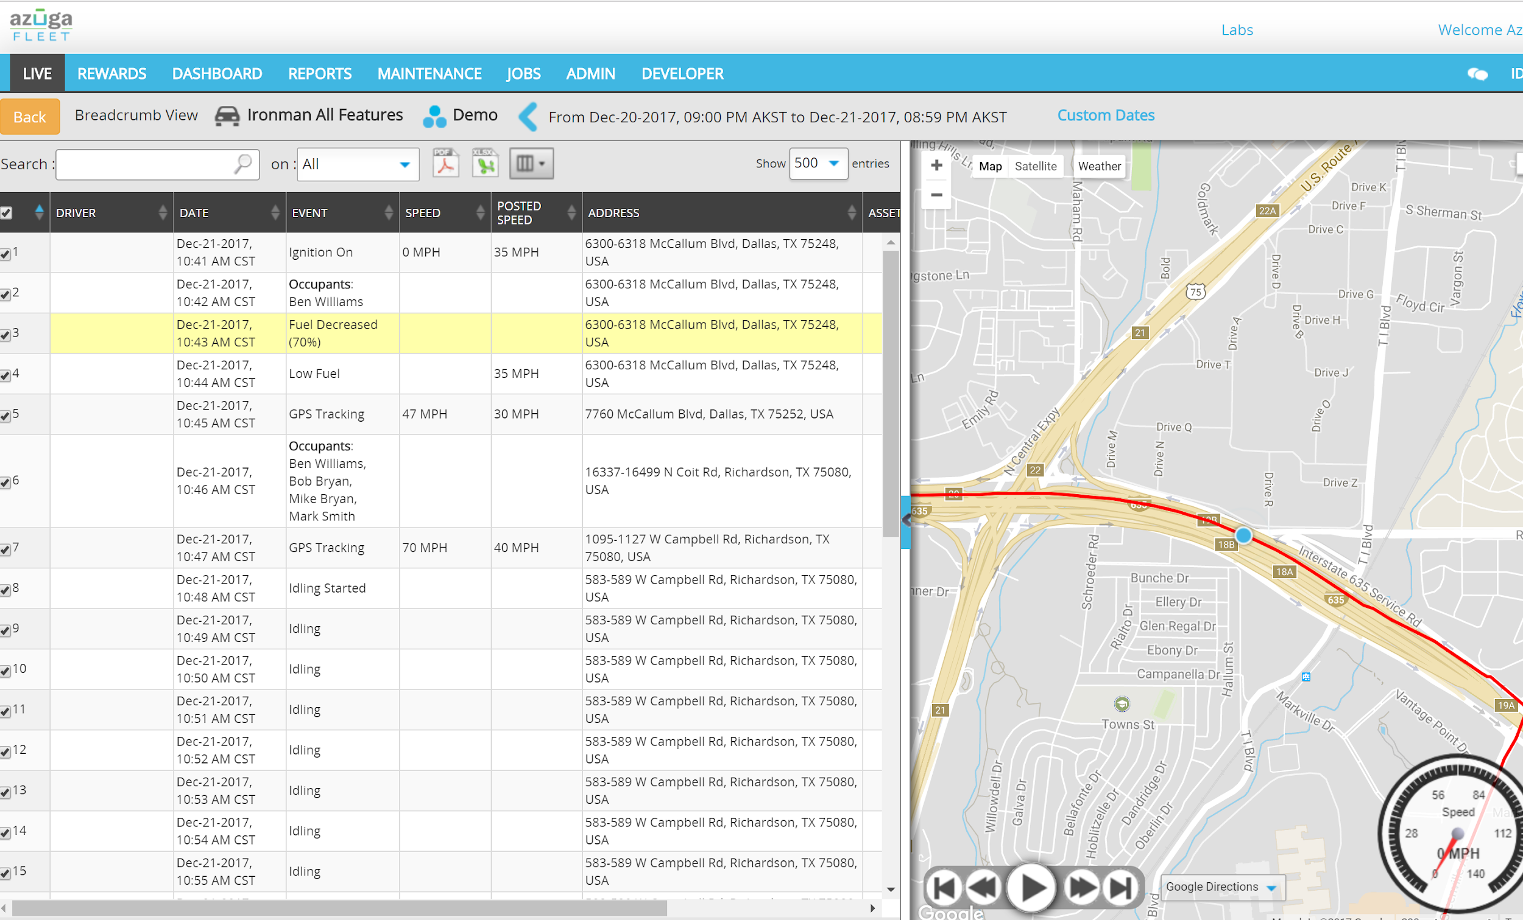
- Looks like there’s some driving behavior we want to take note of – see that ‘Hard Braking’ and ‘Sudden Acceleration’ and ‘Speed Exceeded’ points. Hard Braking and Sudden acceleration is an indication of driver behavior and that’s risk for the driver and risk for the business (insurance). This is easy for us to do for Azuga since we talk to the engine every second and we have team members who’ve worked at GM and Ford – we think of ourselves as next-gen GPS or beyond GPS
- Hard braking is defined as a drop of 8 mph in one second. We have all tested this in our own vehicles and it really is hard braking. If you have something on your back seat it actually hits the back of the front seats. This is the same calculations that the insurance companies use to determine dangerous driving habits.
- Sudden acceleration is also defined by an increase in speed of over 8 mph in one second.
- Driver safety really should be your number one concern. If you of your employees gets into an accident it causes a whole slew of unfortunate events that impacts not only the company by the employees family. The questions you need to ask your employees is this: “if you were hurt in an accident and out of work for several week what would happen to your family?” (once you say this you need to not say another word for at least 4 seconds so it can sink in).
- We are one of the few companies that can not only provide driver behavior but it is also the most accurate because we are pulling it directly from the vehicle rather than doing it through GPS location calculations.
- You’ll notice a few events related to ‘Occupants’. This can be done by using Bluetooth beacons - credit card sized things - with a 3 year battery life that drivers carry. The beacon pairs up with the OBD device and matches ‘John Smith’ with Device Serial number 1 which in turn is mapped to the Ford F 150 vehicle.
- Let’s take a look at a few more events…
- When the ignition is off it still sends a location every 4 hours just to let you know that it is alive and well.
- Once the ignition is turned on you will see an Ignition On event.
- Let’s go to the satellite view and zoom in on this event so we can see exactly where it occurred.
- To better view this one the map just click on the even here and it will focus on that event on the map to the right.
- GPS technology has come a long way and we use the most accurate GPS chips on the market and that are allowed by the government. Years ago you were limited to about 150’ of accuracy. Now you can get within a few feet.
- Here is an event of him leaving a geofence (explain what a geofence is and what some of the benefits are:
  - Tracks going in and out and how long within the geofence. This is great for job costing (labor) and proof of service.
  - Most businesses don’t want their customers or potential customers to see their vehicles are a Men’s Club or other locations that could damage the company’s good name so you can also use geofences to let you know if any of your vehicles are in “undesirable” locations.
- We have a few more hard braking events. Let’s zoom in and see what the story might be. This one occurred just before a stop sign. You always see a stop sign well before you get to it so a hard break just before usually means the driver was distracted or in a real hurry.
- With this many driver related events it is clear there is a problem here.
- BUSINESSES HAVE NEVER HAD THIS DEPTH OF INFORMATION TO HELP THEM MANAGE THEIR FIELD OPERATIONS, VEHICLES, AND DRIVERS.
- Now, I’ll show you a ride-along – I am going to click on ‘Play’ and you can see the breadcrumb trail – let me speed it up a bit with a fast-forward – this ride-along can help you identify any off-route behavior. You would be surprised at how much these off-route trips are actually costing you and your business.
- We can speed it up by clicking the Fast Forward.
- And finally go directly to the end of the route by clicking here.
- So with the Live Fleet we have something that is at a glance and then you can drill down if you want.
OK. Let’s take a look at the dashboards.
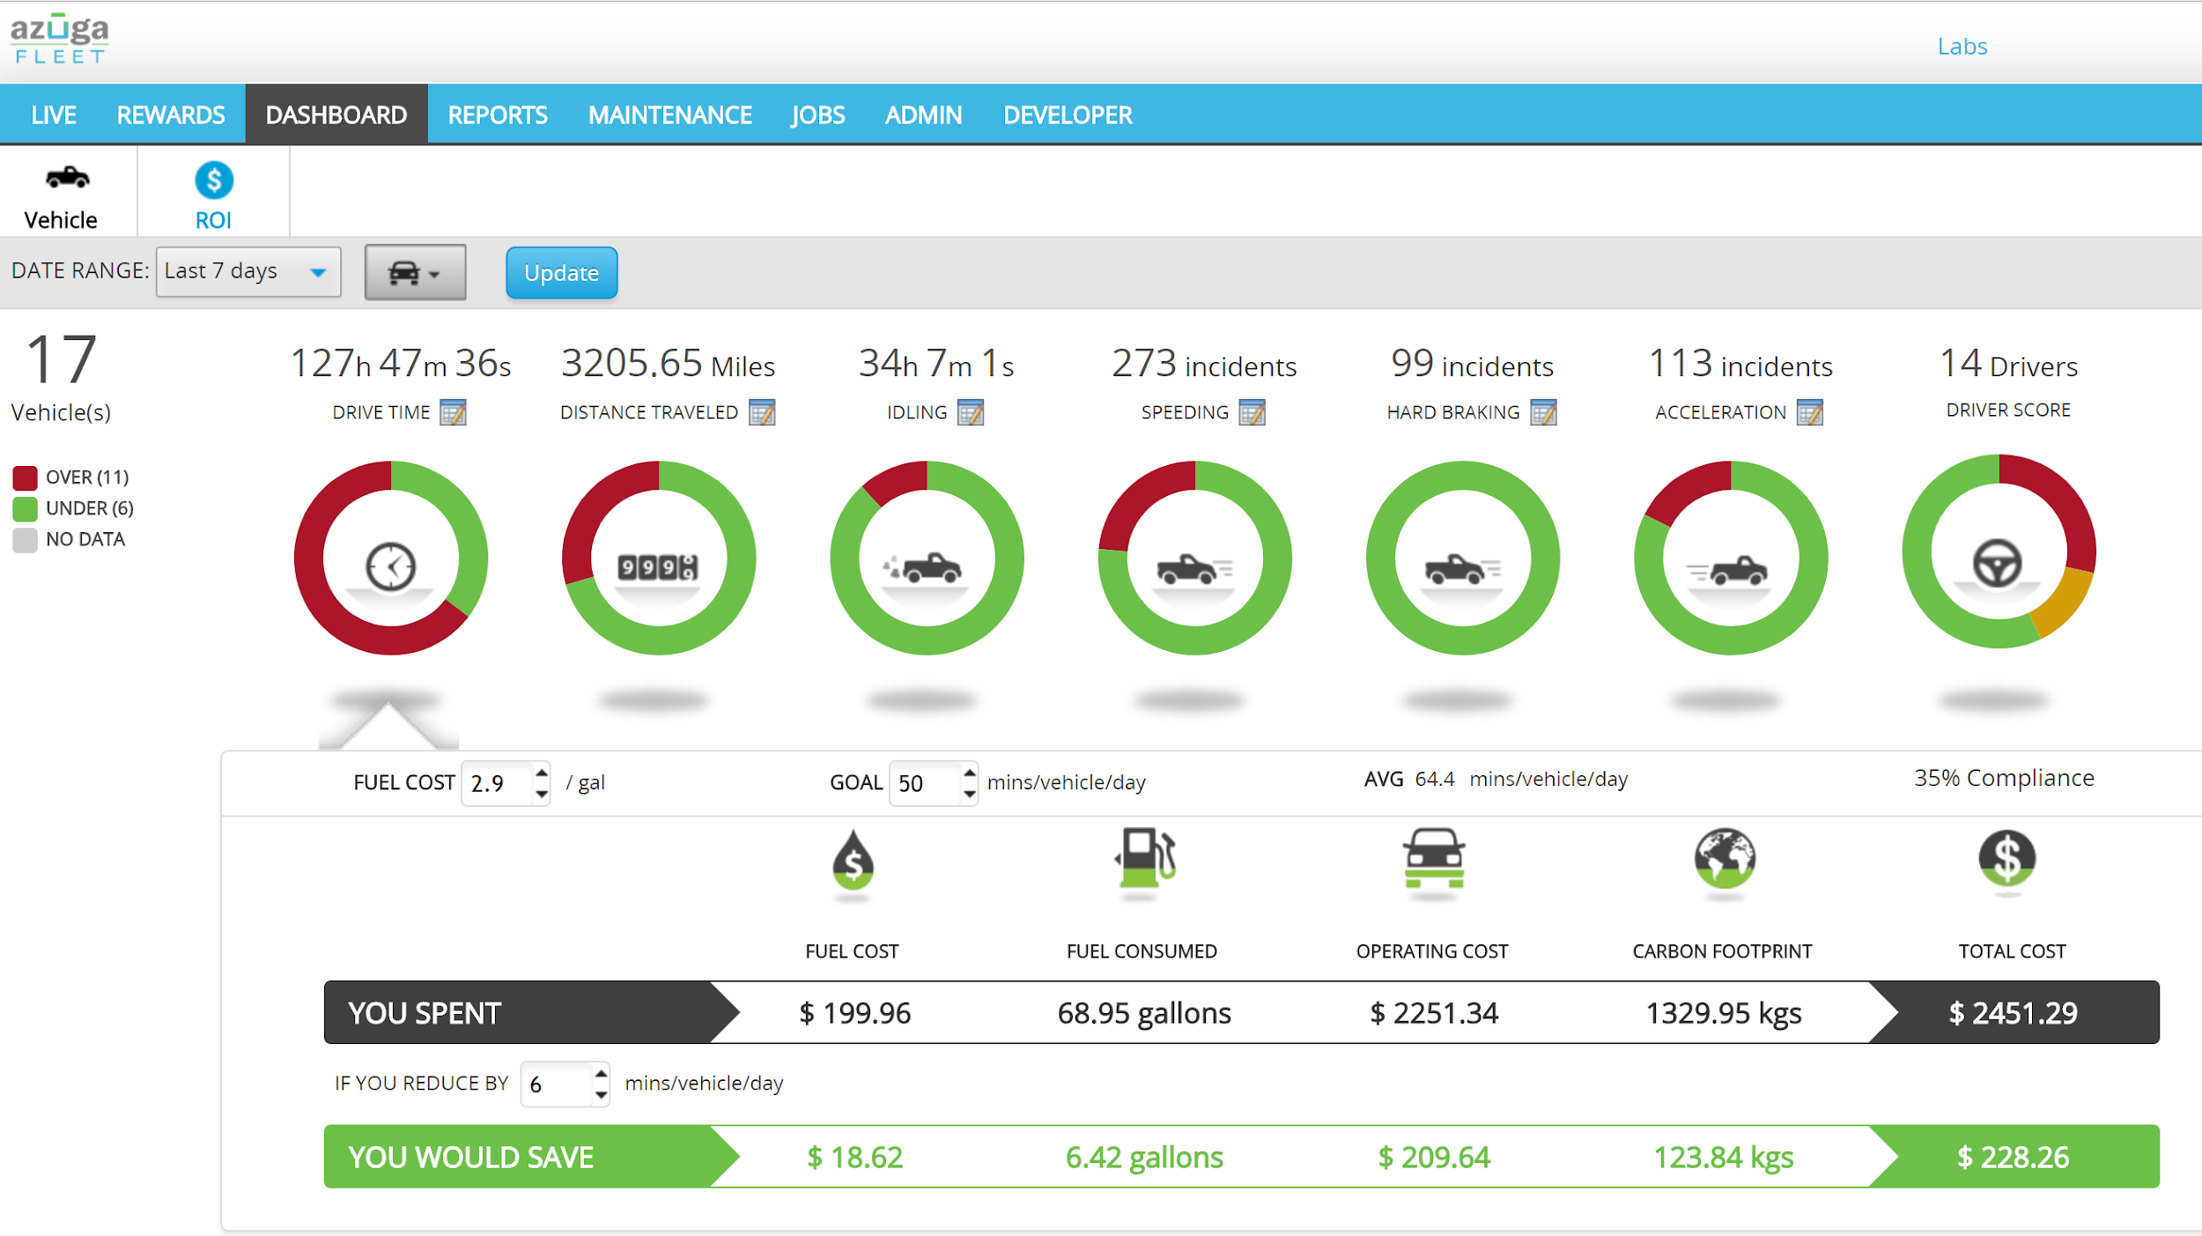

- This is your 5 second “how is my operation doing” view.
- < Unlike others, say something here. Example. Our customers tell us that our app is intuitive and easy to use. This is another example of operational data at your fingertips. Would love to hear your opinion>
- <If you were forced to skip the slide deck and had to jump to this demo, say a little bit about how we are different. You see the ROI tab. This is real data from your vehicles. And it compares you with other fleets in your industry so you can determine if there is more money to be saved. This is a unique built-in ROI feature. You don’t have to go looking for an excel calculator that someone sent you when you were first buying GPS software. It’s right there. Live.>

- This will let you know if something needs your attention without digging through 27 different reports.
- It also allows you to run a variety of “What if” scenarios so you can see the financial impact to your field operations including reductions to your carbon footprint.
- In this example we are monitoring the daily miles driven.
- The threshold is set to 110 miles a day per vehicle. You can set it the appropriate threshold based on how many miles are typically driven each day.
- The green section show percentage of vehicles that are in compliance and the red indicates the percentage that is of compliance.
- You just click here to see the specifics…
- This bar graph starts with the out of compliance vehicles and moves down to the vehicle that in compliance.
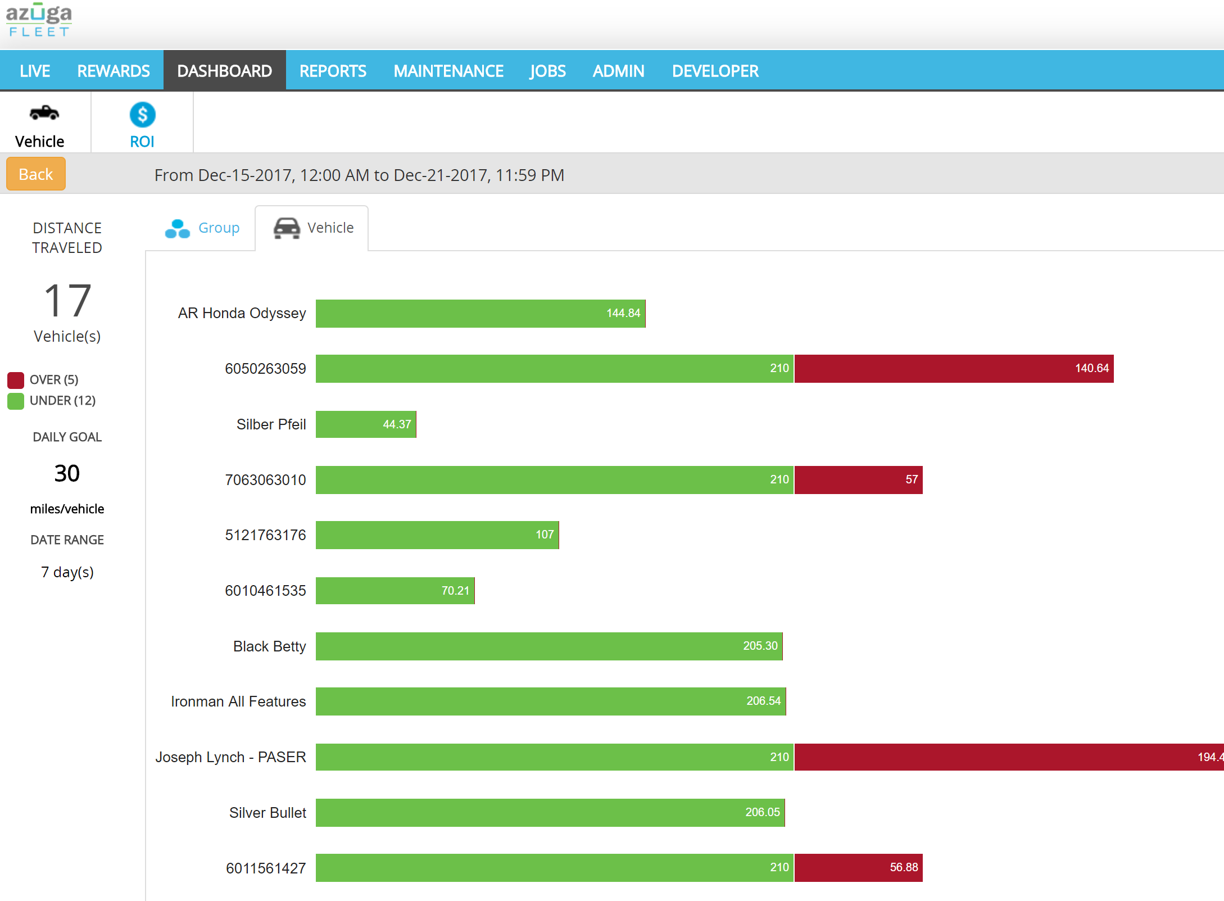
- Based on this I would check with these 4 employees to find out what the story is.
- After the first few week of using Azuga and working with your employees you will start to see a fair amount of self-correcting behavior. Especially when it comes to unmanaged usage of the vehicles and the employees driving behaviors.
- ROI - There are many questions on Fleet ROI. Usually, you receive a ROI calculator during the sales process. It comes in the form of Excel. It looks really good. But its hard to find a year later when someone in your company says ‘Are we saving money with Azuga’. Well, we’ve got a live one here!. Not only does it tell you where you stand, but it also tells you where you stand in comparison to other companies in your industry, and with fleets of similar size…
- 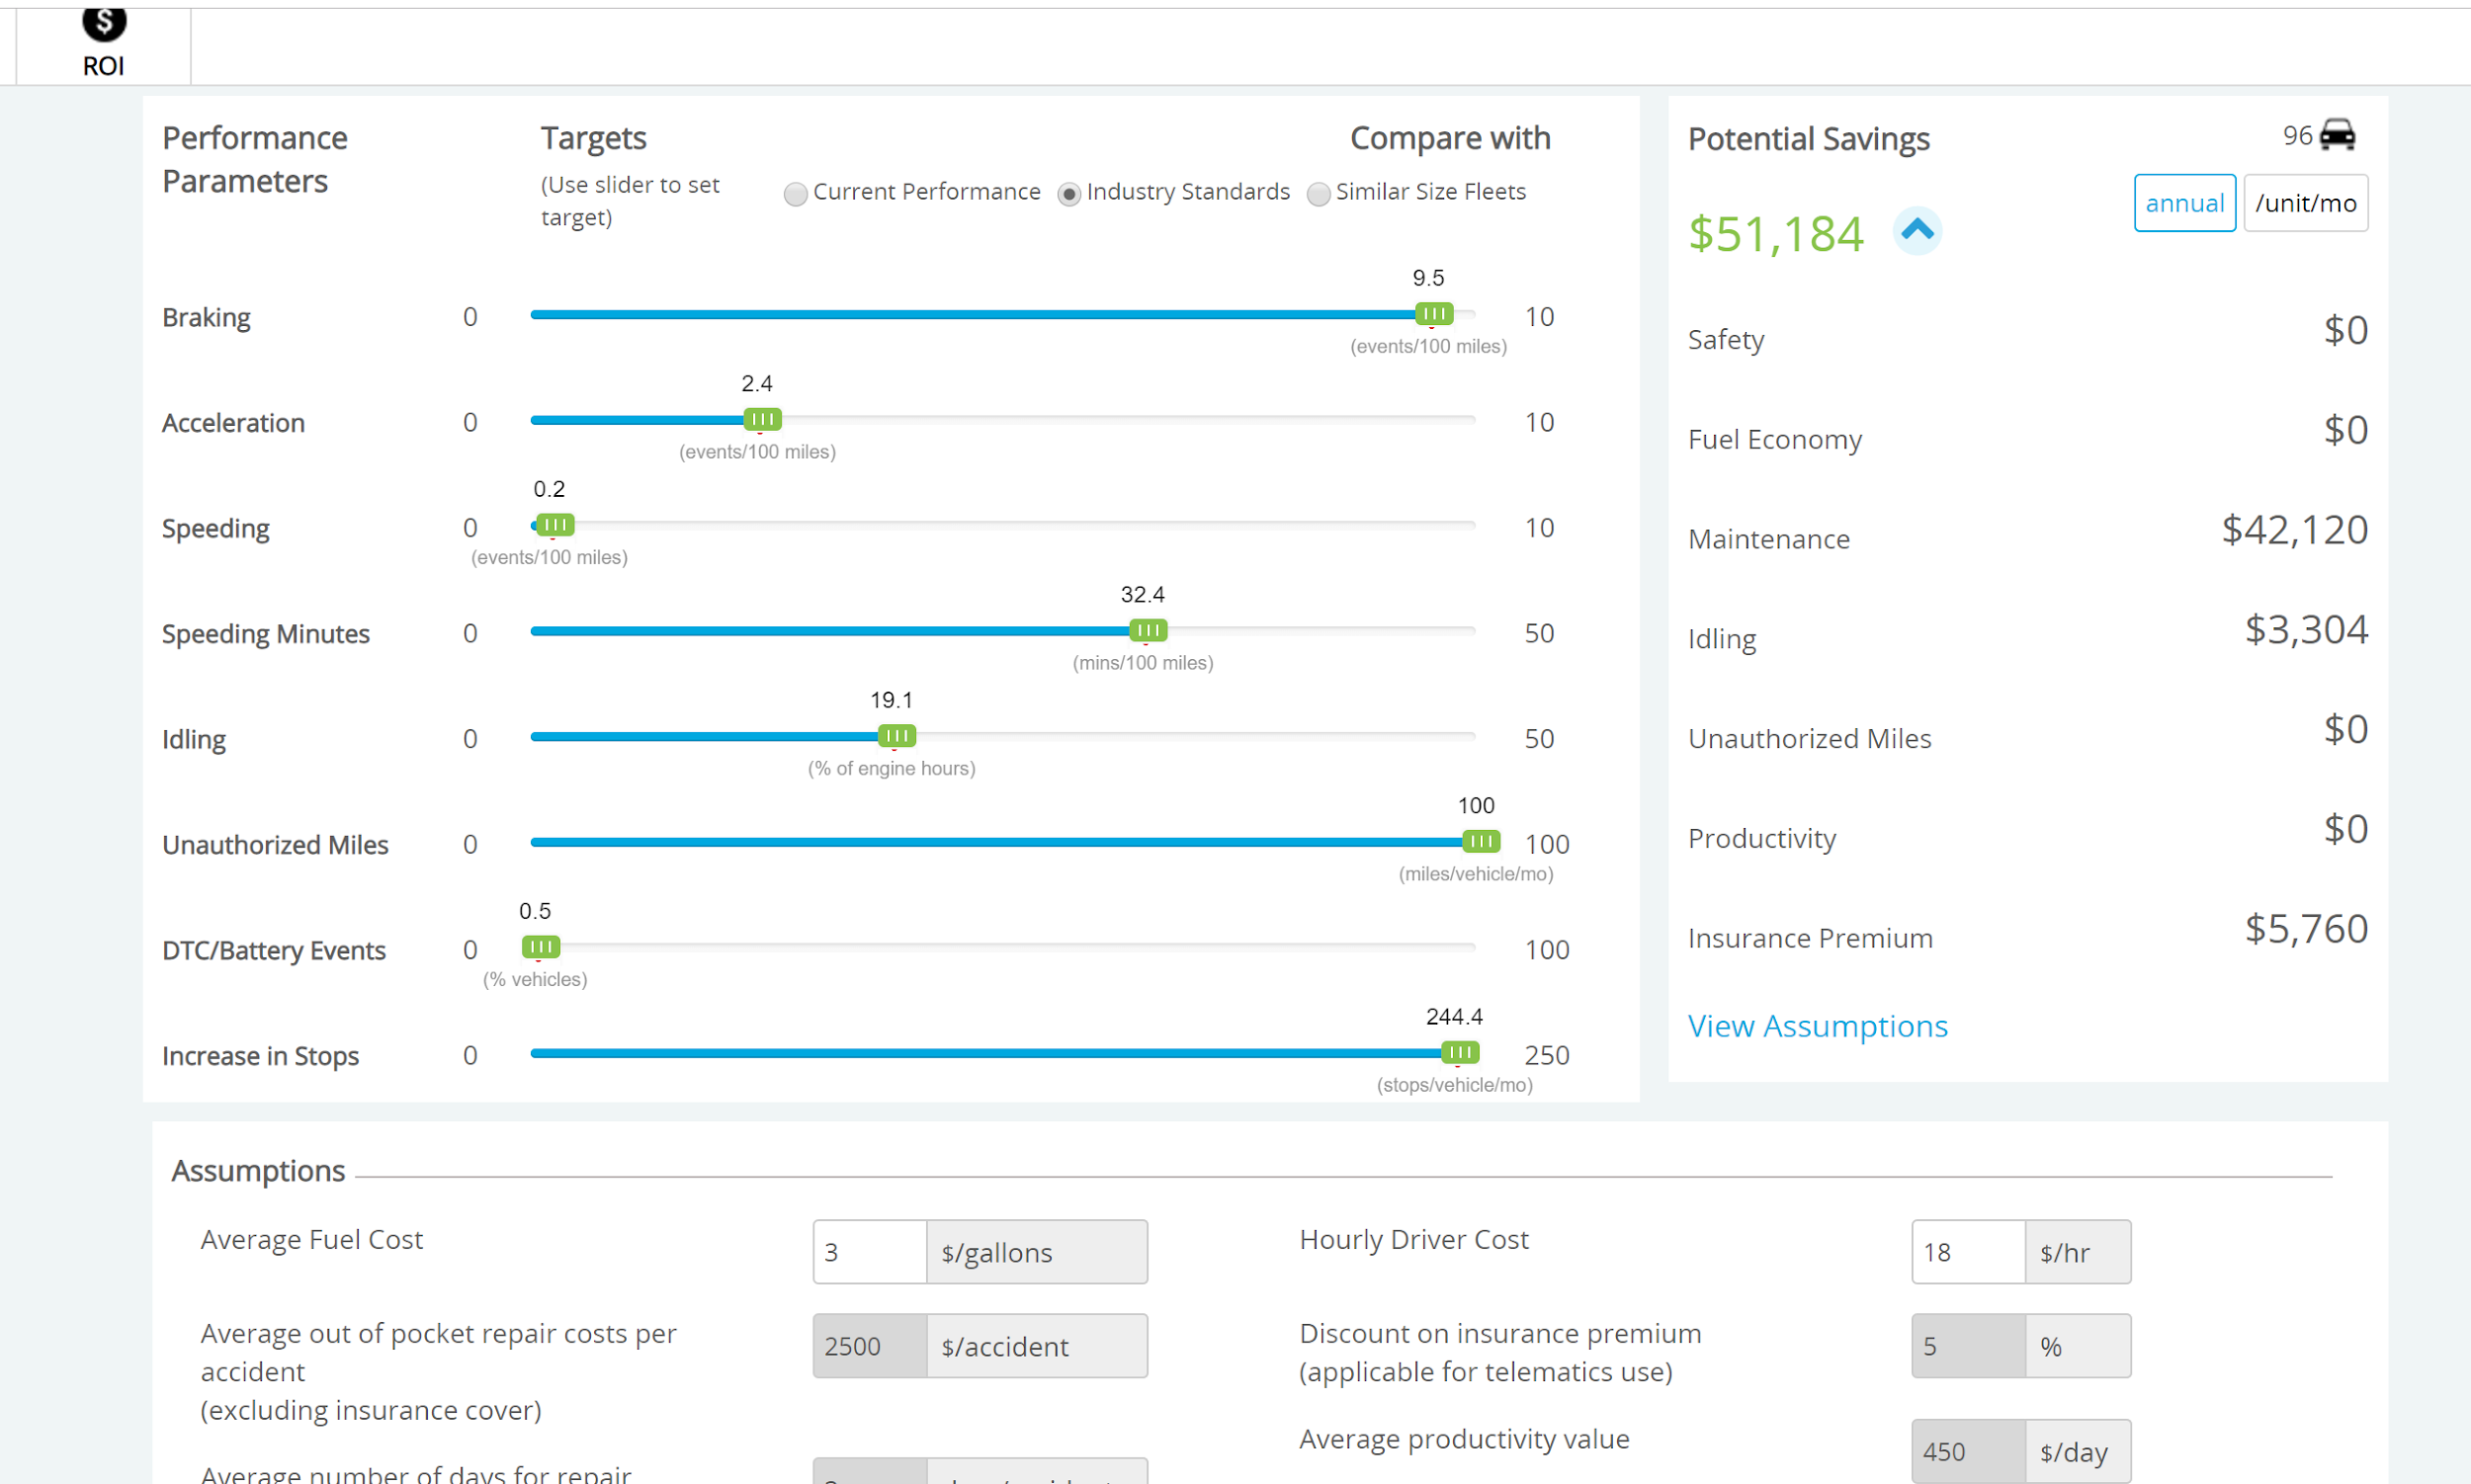

Azuga firmly believes that ‘attaboy’ is better than ‘gotcha’. We also realize that business value and impact is the primary objective. To that end, in addition to all the operating benefits you see, we’ve built a rewards platform that you can use to reward your best performing drivers. First, we have a driver score report. And a simple classification: Safe, Watchlist, Risky
If drivers have the Azuga FleetMobile app, they will see this on their phones….and a leaderboard. When Drivers Compete, Everyone Wins!. A little bit safer means lower fuel, lesser risk, fewer accidents.
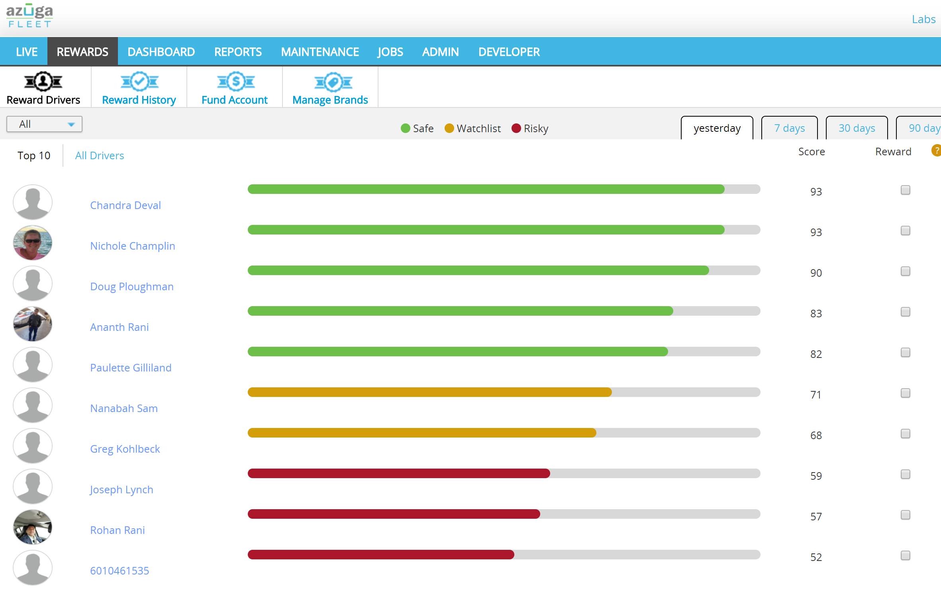

Clicking on the picture shows more detail on the driver score
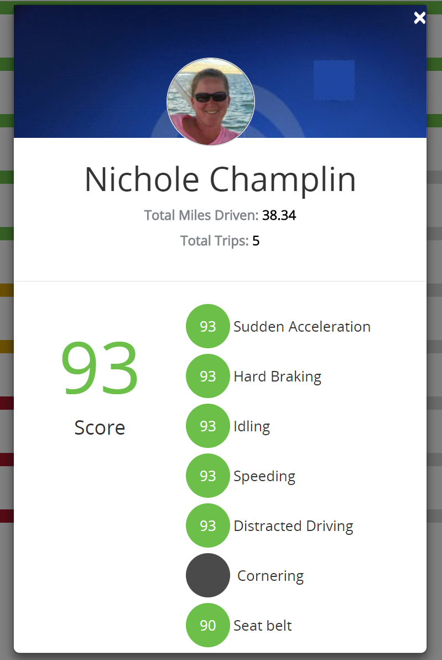

But wait - how do you make sure that these scores and leaderboards last - sometimes drivers can be competitive for a while and then the newness wears off
Well, we’ve got a solution for that with our Driver Rewards platform.
Fund the account. Push out $25 to your top driver on Friday morning. They can redeem that against these brands. There’s plenty of research out there that tells you that smaller rewards, distributed more frequently keeps up driver engagement - and in this current economy with low unemployment - you want to to everything you can to retain your top drivers.
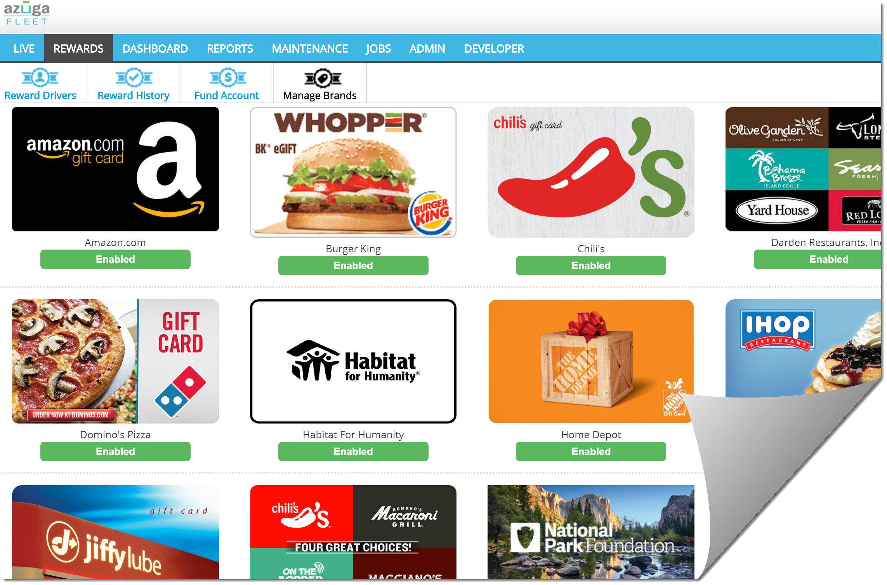

Combing back to reports…..

The summary report is a very useful report. Like a dashboard but rows and numbers
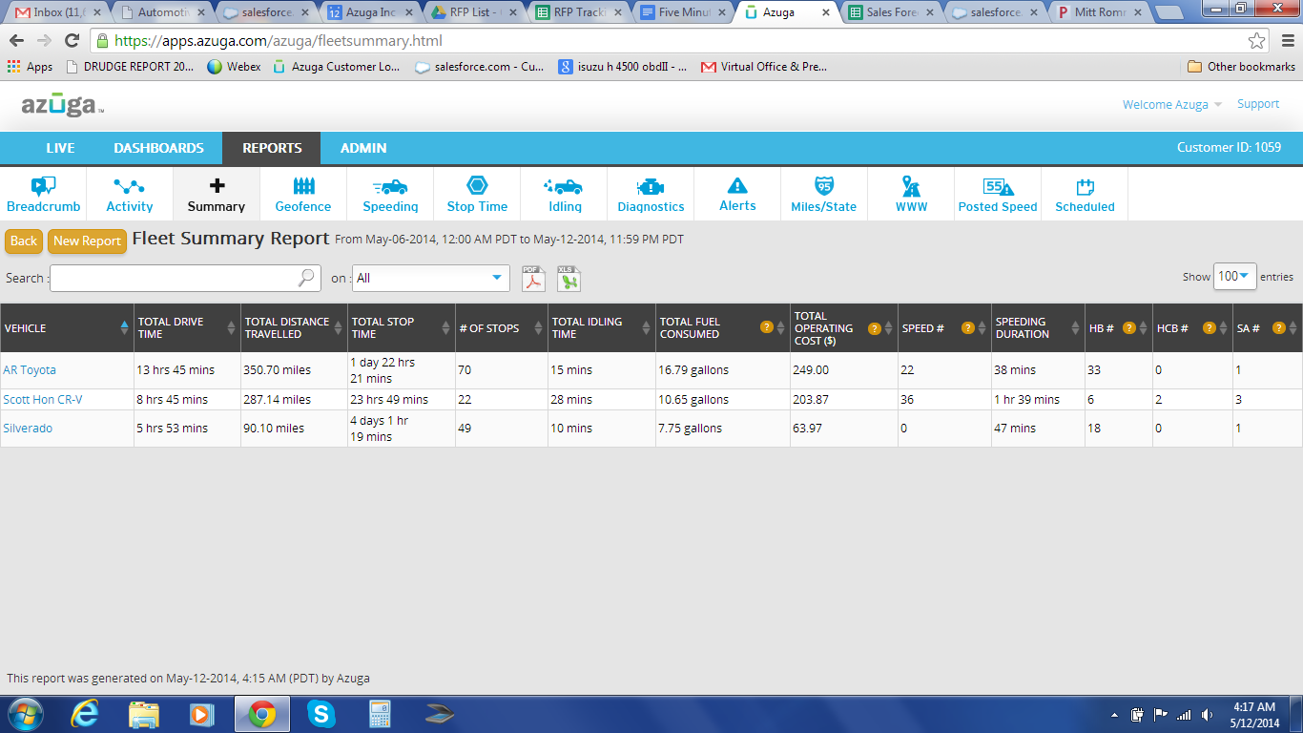

Let’s go back to reports
- The Summary Report covers a range of time that you determine. A week or a month.
  - The time and location for when the ignition was turned on and then off.
  - Total Drive Time
  - Total miles drives
  - Stop time
  - Number of stops (
  - Idling
  - Fuel Usage
  - Your total cost to operate the vehicle
  - And Driver Behavior
There’s a lot more reports. Azuga is used by customers with 20 vehicles to 2000 vehicles. We have a team of people focused on custom reports….just in case you need data in a specific way.
Engine Diagnostics Report
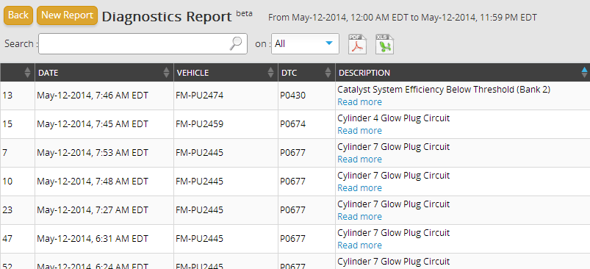
- This report would show the diagnostic codes when the check engine light comes on. Fortunately all of the vehicles in this demo account are healthy but if the check engine light did come on this report would tell you what the code is, what it means and provide a link for more information about that code.
- One of the first Alerts you will want to set up is the Check Engine Light notification. This notification can also be sent to your mechanic so they can let you know if the driver needs to pull over or has time to get it to a shop.

Alerts
- Alerts can be set up when you go to the Admin Tab. Let’s take a look.
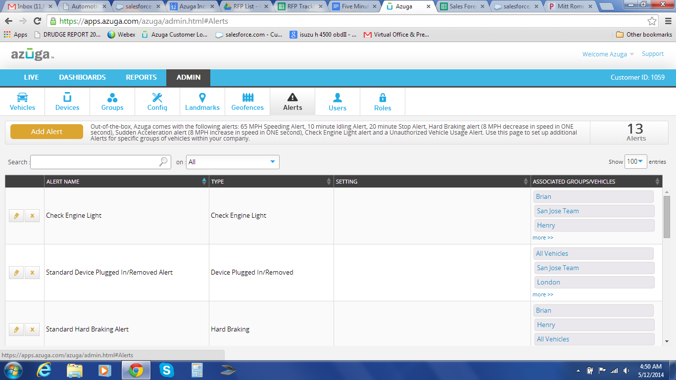
- This tab will show you your active alerts and also where you can setup alerts. To see all of the alerts available and to setup an alert just click on the “Add Alert” button
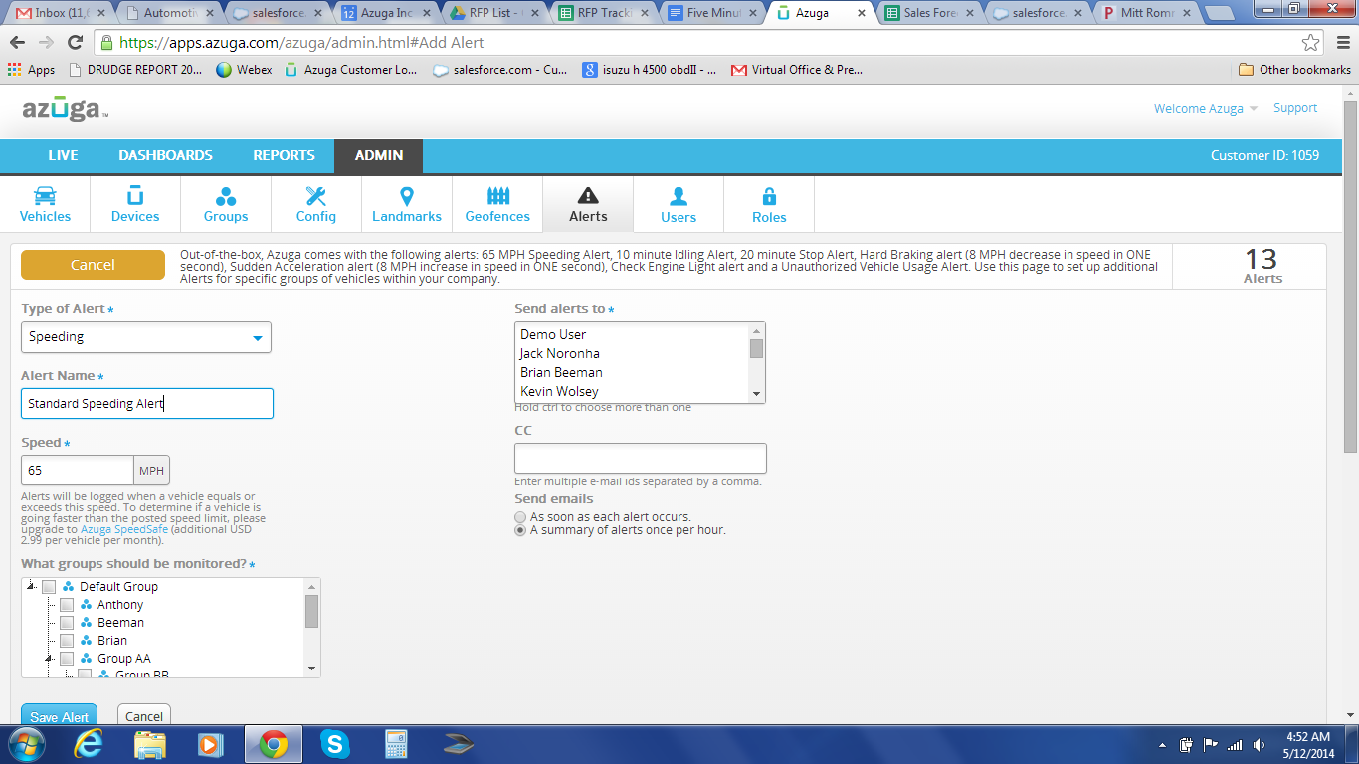
- From here we click on the pull down in the Type of Alert field to see all of the available alerts

- Let’s take a quick look at the Scheduled Maintenance alters (Quickly explain how this works)
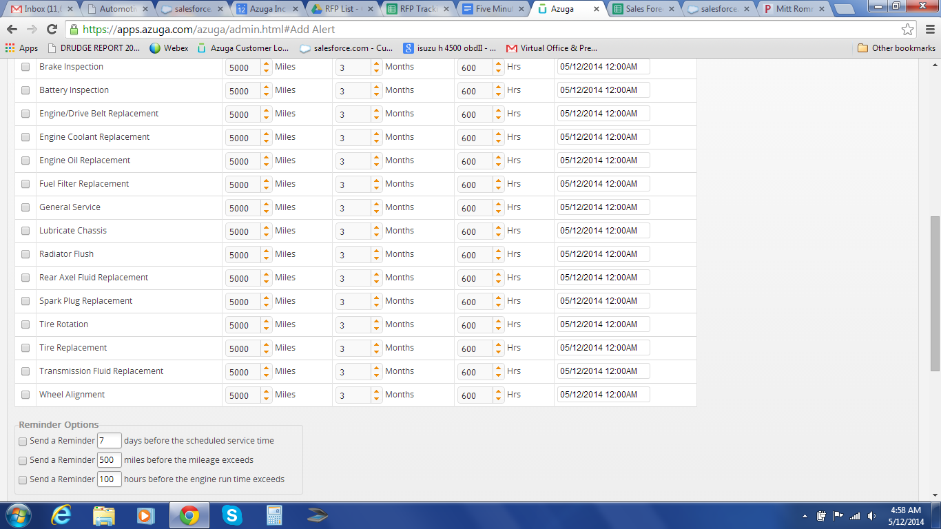

Unauthorized Vehicle Use
(You should know by this time if the prospect lets employees take the vehicles home at night or not. Either way you want to show them how to set this up.)
- “Since you keep the vehicles at the shop/let employees take the vehicles home I think you are going to like this.”
- “ If an ignition is turned on during the hours you set you will be notified. You will be surprised on what you see in the first few weeks.”
Check Engine Light
- “We have dozens of customers who have told us that, as it turns out, some of their drivers keep driving and never tell someone that the Check Engine Light was on until they get the broken down vehicle towed to the mechanic. Now your mechanic can be notified the second it lights up.
Finally, we all know that Fleet GPS is all about driver acceptance and how you manage the data. Hopefully, you’ve found our product easy to use…..but let’s about getting drivers to be happy!.
This is where Azuga is different than everybody else.
OK. It has taken a little longer than 5 minutes but I wanted to give you the quick overview first so I am open for questions. What you saw today is a demo account that has all the features layered in. Our pricing starts at $21.99.
Demo to close:
Social proofing genius - Stolen from Charlotte: If you have a minute, I can conference in Steven at Earthtech Landscape if you want a quick reference.
Demo to trial (only if needed)
I can get a free trial going for you. Completely painless to you. No credit card needed. Free shipping. All I need is your shipping address.

